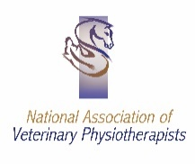
Veterinary Referral Form – Veterinary Physiotherapy
Ephie Nash – BSc (Hons) Veterinary Physiotherapy. Member of National Association of Veterinary Physiotherapists.
Professional Liability Insurance: Balens ZUR-BAP/20/01/559
Please return completed form to nwvetphysio@gmail.com or call 07398218580.
Animal Details
Name: | Sex:  Neutered (Y/N):
Breed: | Insured (Y/N):
Age / Date of Birth: | Insurance Company:

Client Details
Name: | Contact Number:
Address: | Email:

General Health Details
General Condition

Weight/BCS
Vaccinations
Temperament

Case History
Current Problem / Reason for Referral (Maintenance, Rehabilitation or Performance)

Pre-existing Conditions

Current Medication

Any other relevant history/information (please attach notes/radiographs if applicable)

Declaration for Veterinary Physiotherapy
This animal is a patient under my care and is in my opinion fit to receive veterinary physiotherapy treatment. I authorise veterinary physiotherapy for my patient to be carried out by Ephie Nash.

Signed: | Date:
Print Name: | Phone:  Email:
Practice Stamp: | Practice Address:
Written report provided following initial assessment with details of findings and treatments

Email Post Telephone NO

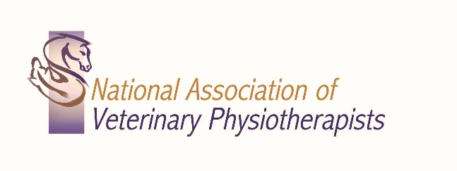
I take full responsibility for my work and the outcomes and will immediately refer the animal back to you if I see any signs of underlying injury, disease or pathology. I am governed by the NAVP Code of Conduct which I fully observe.
Signed: Ephie Nash – North Western Vet Physio.
Date:
I

